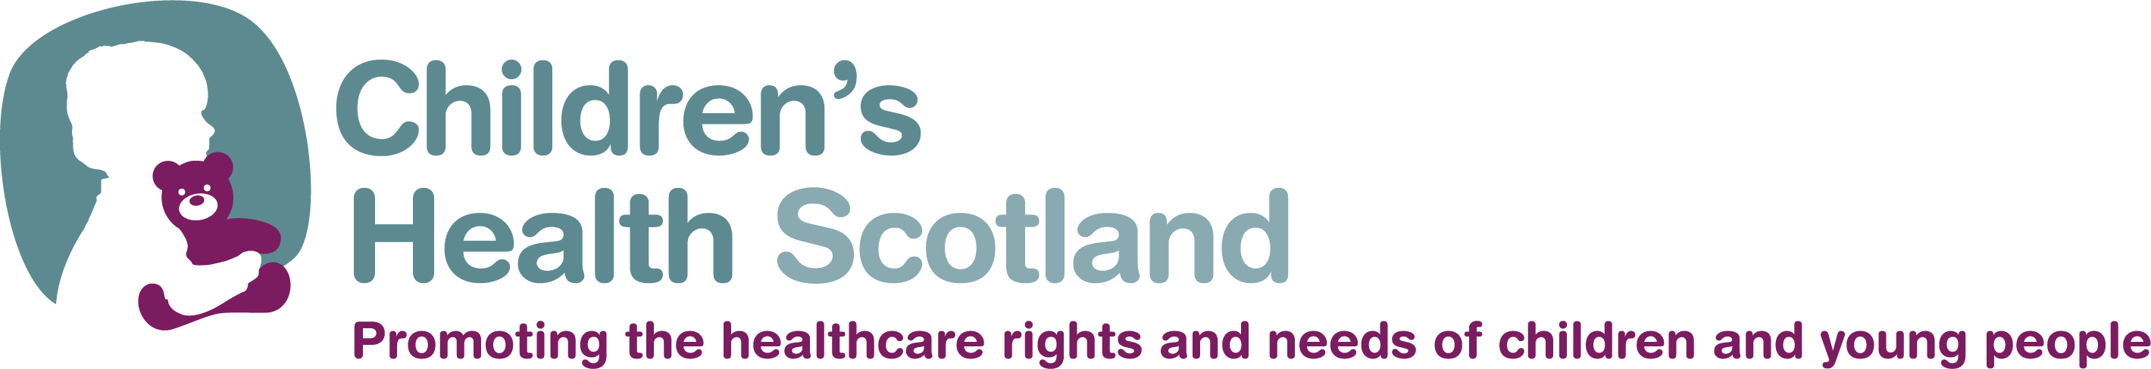
Family Participation (having a say in shaping and delivering child healthcare services)

Introduction
A great deal of recent legislation and guidance on health, education, social services and the early years requires the involvement of users in planning services. Increasingly, government agencies, health boards and other organisations are involving families in shaping services because it benefits everyone and can lead to a more efficient and cost effective service.
Children’s Health Scotland, formerly known as Action for Sick Children Scotland, is involved at all levels of planning and policy making locally and nationally and we do this with input from families – parents, carers, grandparents, kinship carers and children and young people themselves. It is your knowledge, experience and needs which inform and shape our work. We do this in different ways and the following examples show some of the forms participation can take.

Cases /Examples
- At a conference organised by the Scottish Association of Community Child Health, on the theme of transition, two parents took part in a joint interview which described the experience of their young people when moving from child to adult health services.
- Health Rights Information Scotland (HRIS) asked us to collaborate on the production and user testing of family information leaflets describing resuscitation planning for children and young people which they were producing for the Scottish Government. Although this is a specialist area, we were very pleased to be able to help in this important work by identifying parents and professionals to take part.

- Around the subject of long term conditions, we have had two young people describe very eloquently how they manage their lives while living with two different long term conditions. One young woman spoke at a conference given by the Scottish Government and the other young man was interviewed by us for a newsletter article which was subsequently made into an ipod interview for a national organisation’s website.

Participation Plan
We are building a core group of families – parents, carers, children and young people, including family support groups - interested in having their views heard by policy makers in order to shape health care services. We therefore invite you to participate and tell us to what extent you would like to be involved - whether you only wish to receive information to keep up to date with developments in child health or whether you would be happy to participate more actively in some of the ways mentioned here.
We would be very grateful if you would take a few minutes to complete the following questionnaire to help us in this work.
We would like to assure you that all of the information you provide will be treated in the strictest confidence in accordance with the Data Protection Act/our Data Protection Policy.
………………………………………………………………………………………………………

Questionnaire

- If you were offered the opportunity to contribute your views to child health service planning, would you be interested in participating?
YES If yes, please go to  (Q. 3 and Q. 4 below) | NO If not, why not? (Q. 2)

- Can you tell us why you would prefer not to participate?
……………………………………………………………………………………………
……………………………………………………………………………………………

- Tick the kind of activities you would be interested in:

- I wish to receive information only

- Being part of a committee, forum etc.

(e.g. Patient Safety Group, Local Health Board Child Health Forum)

- Responding to consultations *

- Comment on patient publications and policies *
(e.g. Health Rights Information Scotland leaflet,

CYPADM Resus information)

- Interviews *

(either to provide an article for a newsletter or web-based interview)

- One-off focus group to gather users’ views

(e.g. National Delivery Plan stakeholders’ seminar
at NHS Forth Valley)

- Contributing to a DVD
(either actively or giving your views)

- Conferences

(e.g. from presenting to assisting on the exhibition stand)

- Regular involvement in focus/subgroups

(e.g. for Scotland’s Disabled Children – Education Task Group

- Short life working/planning/steering group

(e.g. Complex Care Short Life Working Group for
Community Nursing, planning group for Transition conference)

- The information in the following question will help us to identify who best to approach for particular requests.
Is there a child in your family now or in the past affected by a specific health condition(s)? If so, please describe:

……………………………………………………………………………………….
……………………………………………………………………………………….
……………………………………………………………………………………….

- Have you ever had the opportunity previously to have a say in how child health services have been developed or delivered? If so, please describe:
………………………………………………………………………………………..
………………………………………………………………………………………..
………………………………………………………………………………………..
………………………………………………………………………………………..

Thank you very much for taking the time to complete this questionnaire, please enter your details below and return to the address at the foot of the page either by post or email.

- Name: ……………………………………………………………………

Address: …………………………………………………………………
…………………………………………………………………
…………………………………………………………………
Postcode:…………………………………………………………………
Email: …………………………………………………………………
Phone: ………………………………………………………………..
Mobile: ……………………………………………………………….
Other - Facebook, Twitter etc. ………………………………………
Preferred method of contact: ……………………………………….

Children’s Health Scotland is a Company Limited by Guarantee.
Registered in Scotland, Company No. 100114, Scottish Charity No SC006016.
Registered Office, 22 Laurie Street, Edinburgh EH6 7AB.
Email: a.wilson@childrenshealthscotland.org
Telephone: 0131 553 6553
www.childrenshealthscotland.org

