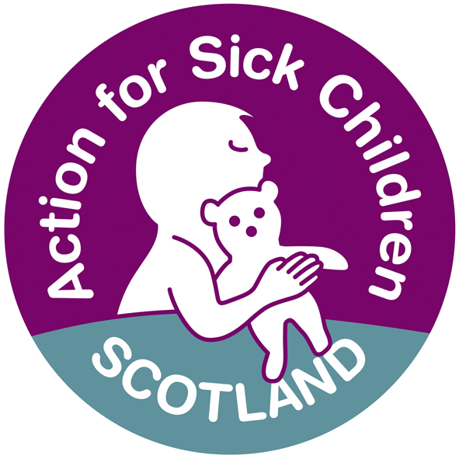

General Medical Council: Tomorrow’s Doctors 2009
Response on Consultation by Action for Sick Children (Scotland)
About Action for Sick Children Scotland
Action for Sick Children (Scotland) has for more than thirty years campaigned for children and young people to receive the highest standard and quality of care when they are ill in hospital, at home or in the community. Whilst our core purpose remains that of influencing and collaborating to secure best health care outcomes for sick children and young people, our activities also reflect the dynamic developments in the planning and delivery of health care in Scotland today. We work in partnership with parents, carers, health care professionals and most importantly with children and young people themselves.

Action for Sick Children (Scotland) (ASC(S)) is a member of the European Association for Children in Hospital (EACH). A key focus for members is the EACH Charter and its ten Articles which explain the rights of children, young people and families when using health care services. The EACH Charter is underpinned by the United Nations Convention on the Rights of the Child and members aim to have the principles of the Charter incorporated into their countries’ health laws, regulations and guidelines. We are delighted that the Scottish Government has recommended in Delivering a Healthy Future: An Action Framework for Children and Young Peoples’ Health in Scotland, that the EACH Charter is to be used by NHS Boards as a standard against which to assess their child health services.

ASC(S) works in partnership with parents, carers, professionals and children and young people to enable them to access best quality healthcare provision. We do this by collaborating at both national and local level on government policy and steering groups and regionally and locally through Health Boards and regional planning groups. Our staff around the country work closely with families, children and young people as our children and young people’s health rights project demonstrates, with its accompanying resource pack and DVD developed by children and young people themselves.

The proposals are broadly welcome and are largely uncontroversial. However in relation to curricula and assessments, Action for Sick children (Scotland) is concerned that there is insufficient emphasis on the fundamental skill of diagnosis without which no doctor can function adequately. Furthermore, we are not convinced that the external examiner system is sufficiently robust to ensure that standards are equal across UK medical schools. A national examination should be used to ensure that minimum standards are achieved in all disciplines as well as across all outcomes in all UK medical schools.

In relation to children specifically, we are concerned that curricula based on generic outcomes, do not ensure that students graduate with adequate paediatric knowledge and skills. Although paragraph 98 states that "there must be no compensatory mechanisms which would allow students to graduate without having demonstrated competence in all the outcomes", many (if not most) assessments have compensatory mechanisms which allow students to graduate without displaying competence in particular disciplines, including child health. It is thus perfectly possible to learn tactically and graduate with little or no knowledge of child health provided adequate scores in the outcomes is achieved.

The lack of a minimum standard of child health knowledge and skills is particularly worrying in view of the fact that children constitute just under 20% of the population of the UK (but 30% of its life expectancy) and make up 25% of an average general practice workload. The fact that many adult diseases have their origins in childhood is now widely accepted and further emphasises the importance of children’s health.

The length of core child health curricula across the UK varies by a factor of two, with one of the shortest in Scotland comprising 6 weeks in total. Since a significant minority of GP vocational training schemes have no paediatric content, the core child health component of undergraduate curricula assumes a greater importance. A national curriculum (coupled with a national final examination with minimum standards in individual disciplines) would ensure that all students were able to achieve an adequate standard of knowledge and skills in child health and paediatrics.

The public has a right to expect that all graduating students have a basic grounding in paediatrics and child health to the extent that they are competent to manage common paediatric conditions and emergencies. We are of the opinion that this is not currently the case nor will it be under the proposals contained in “Tomorrows Doctors 2009”.

There is little or no mention in the Consultation Document about paediatrics and specifically dealing with child patients and we would refer to the presentation from the Tomorrow’s Doctors consultation event in London which is on the GMC website. This presentation outlines what the public need from their doctors. The last slide quotes Katherine, aged 8 as saying, ‘Doctors should be nice and friendly and not scary. They should make you better without hurting you’. We would emphasise that the very valuable points made in this presentation eg
‘that doctors should explain things in a way I can understand, listen to me, treat me with dignity’ etc. apply as much to children as to adults and that children have the right to the same standards as adults. ASC(S) believes therefore that undergraduate training must include training in communications skills in dealing with all patients, including children and those with communication difficulties. These communications skills need to enable individual Doctors to recognise their own limitations and to know how to use the specialist help available eg use of hospital play specialists to prepare children for surgery or independent advocacy services for those with additional support needs. This training also needs to put across that communicating with patients (including children) has to involve communicating directly with the patient and those who may be the patient’s advocate or guardian.

ASC(S) is aware through our work of the impact a healthcare experience can have on a child throughout childhood and into adulthood. A negative or frightening experience can result in a lifelong aversion to accessing healthcare, attending appointments etc. Trainee doctors need to be made aware therefore that the age and developmental stage of a child can impact on the child’s understanding of the doctor’s behaviour and response and the doctor needs to tailor his communication accordingly. See EACH Charter Article 4: Children and parents shall have the right to be informed in a manner appropriate to age and understanding and Article 8, Children shall be cared for by staff whose training and skills enable them to respond to the physical, emotional and developmental needs of children and families.

It will also be important for doctors to recognise the impact of illness and medical treatment on children’s educational experience and how crucial education is to a child’s development. Doctors need to recognise therefore that the child and their carers may have to prioritise health needs and educational needs differently from an adult who is sick and absent from work. Children at times of illness, particularly those who suffer from long term chronic illness and frequent absences from school still require to have their learning needs met, missing out on education further disadvantages them in terms of life choices and chances. Article 7 of the EACH Charter States that at times of illness, children shall have full opportunity for play, recreation and education suited to their age and condition and shall be in an environment designed, furnished, staffed and equipped to meet their needs

Any training about the cultural and spiritual needs of patients should take into account that children can be affected by their parents’ cultural beliefs and so cultural awareness should encompass children as well as adults.

Action for Sick Children (Scotland) would also stress the importance of the need for doctors to understand what it means to be a child or young person in care. This should not only be seen in relation to child protection but in the wider context of the needs and issues of children who are particularly vulnerable not only in terms of their health and well being but also in societal terms, where a lack of understanding can result in their stigmatisation and subsequent failure of the system to meet their needs.

The following points have been drawn from the findings of Action for Sick Children, Scotland’s current project, Their health matters: Meeting the Healthcare needs and rights of children and young people in and leaving care.

- Navigating the system to access appropriate healthcare
‘We try to focus on the child and I think we need to empower them to have an understanding of their own health and how to take responsibility for that’. (from a GP)
- There is often no one person responsible for or to advocate for them – the children move frequently as do staff
- They are vulnerable both in healthcare and societal terms – not for nothing have they been referred to as forgotten children
- They suffer from low self-esteem and poor self-care – the statistics for mental health problems make stark reading - 50%-96% LAAC population have mental health issues
- They may engage in risk taking behaviours, often manifest in their non-management of a long term condition e.g. refusal or abandonment of treatment which the young person uses as a power tool.
- They often mistrust people which includes healthcare professionals because they have been let down so many times and have no reason to invest in a relationship
- Doctors need to avoid stigmatising or labelling the young person while at the same time being aware of the very considerable hidden agenda that impacts on this group and to have an enhanced awareness of this extra dimension

I like it, ken, when they tak time tae explain an they’ve got that look on their face that says we do care what’s going on wi people (Young person in care referring to Doctors)
We would strongly recommend that these points are taken into account in future training of Tomorrow’s Doctors.

Action for Sick Children (Scotland)

March 2009

