The ABCD of CBT

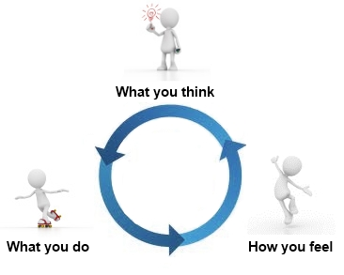

Reminder – We identify our bad feelings, then link the event/situation, then identify the thoughts, then dispute …

Tips for disputing: What is the evidence? What alternative views are there? What is the effect of thinking the way I do? Is my thinking realistic? What would I tell my best friend?

Task: Fill in your own personal ABCD form at the back of the page

A = Activating Event or Adversity | B = Belief/thought | C = Consequence feelings | D = Dispute
For Example:  I have an important exam approaching | ‘I’m going to fail! This is unbearable, I can’t stand it. I’ll never be able to prepare for it, not with life the way it is right now. I’m useless, why am I bothering? There’s no point. | Anxious – can’t sleep – can’t focus. | Stating ‘I’m going to fail!’ and ‘I can’t stand it!’ is irrational. I cannot tell if I will fail. Yes I need to prepare for it. Yes life is complicated right now. But I’m not useless! I have not seen the future but I know I need to give it a shot. I can in fact bear it, it would be more correct to say I’m nervous and would rather not be in a situation where I need to ‘bear’ it. All I can do is by best – and I’m not living if I’m not ‘bothering’.

A = Activating Event or Adversity | B = Belief/thought | C = Consequence feelings | D = Dispute

