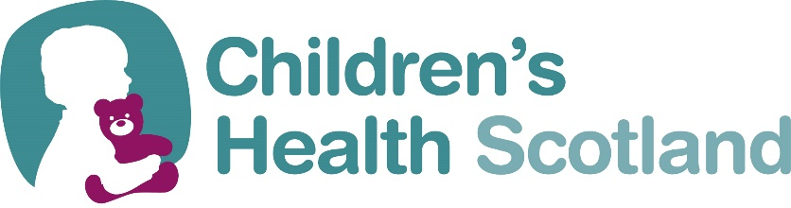

RESOLUTION

I propose that the following resolution is put to the Annual General Meeting of Children’s Health Scotland at its meeting on Saturday 15 October 2022.

Details of Resolution

_________________________________________________________

______________________________________________________________________________________________________________________________________________________________________________________________________________________________________________________________________________________________________________________________________________________

___________________________________________________________________________________________________________________________________________________________________________

Proposed by

___________________________________________________________________

Signature of CHS Member

Seconded by ________________________________________________________

Signature of CHS Member

Please return via email, if possible, to the Chief Executive, Children’s Health Scotland, 22 Laurie Street Edinburgh EH6 7AB by Friday 30 September 2022.
Email: helen.forrest@childrenshealthscotland.org

